**Network Task**

Get me the IP address of a particular domain (guvi.in)

* nslookup guvi.com
* 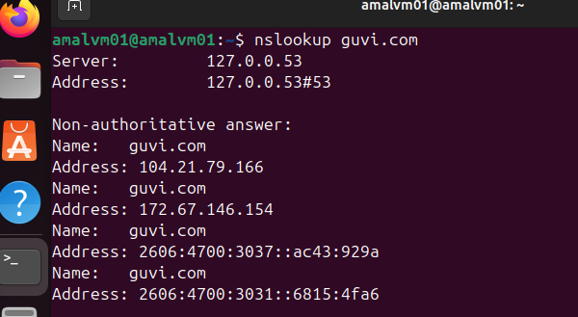

To find my CPU/memory usage of my server

* top
* 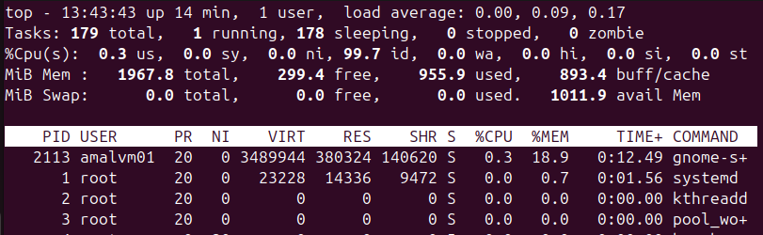

Test the connectivity between 2 nodes

* ping google.com
* 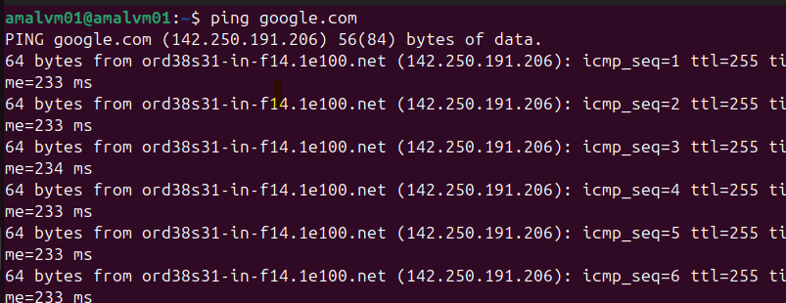

2.I have deployed an application in guvi.com:9000, and logs show my app is running, but I’m unable to view the page. Check whether my port is open or not

* telnet guvi.com 9000
* 